# 4CS017 – Internet Software Architecture workshop sheet

## UML Deployment Diagrams

*What will you learn today?*

You will learn to draw a diagram of your architecture so far.

## Part 1 – Draw an UML Deployment Diagram of your architecture

1. Revise what UML Deployment Diagrams are in this week’s lecture slides.
2. You can use any UML Design tool you like (or indeed pen and paper!), but I recommend this free, browser-based tool: <https://online.visual-paradigm.com/>
   * Create an account using your university email address and password.
   * Log in and create a new “Deployment Diagram” (as you can see there are LOADS of different types of diagrams!)
3. Draw a **Deployment Diagram** of last week’s workshop task, showing the following nodes (hardware and execution environment), artifacts (software elements inside your nodes) and how they link (associations):
   * OpenWeatherMap server
     + Web server software
       - Current Weather Data API
   * Your device (PC, Mac)
     + Your Web client (i.e. Web browser)
       - Your JavaScript script

You should get something like this:

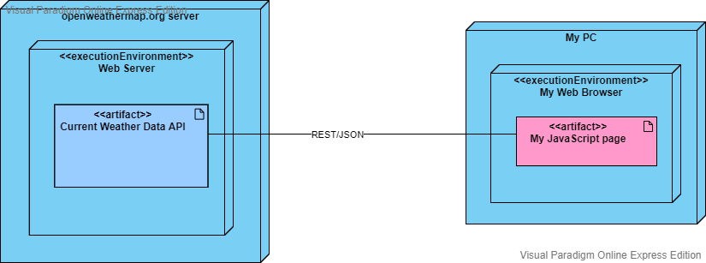

1. Save your diagram for later use (you can also export to an image, to include in your submission). It’s nothing too complicated at the moment, but it will get more complex as we improve our application’s architecture and add more features!

## Part 2 – Going further

*“I have finished all the work above, what shall I do next?”*

* Use the [Geolocation JavaScript API](https://www.w3schools.com/html/html5_geolocation.asp) to obtain **local** weather forecast from the [Current weather data API](https://openweathermap.org/current#geo).
* Add the Geolocation JavaScript API to your deployment diagram (as an artefact inside your web browser node)